freETarget
Application Note: Timed Events

SUMMARY
This application note details timed firing events available in FreeETarget
- Single Stage Rapid Fire
- Sport Rapid Fire
- Tabata Training
The instructions include the setup and use of the feature.
REQUIRED
- freETarget Firmware 6.4.1 or higher
- freETarget PC program 4.12.1 or higher
INTRODUCTION
This version of software is an update to the existing Rapid Fire event firmware. In particular it integrates Timed Fire, Sport Pistol, and Tabata into one interface. In addition it adds the 300ms grace period after the event turns off to accommodate the time of flight of the projectile.
The three modes supported are:
- Timed fire – Shoot a string of shots into a single target.
- Sport Pistol – Shoot one shot into a single target, repeat for the entire session
- Tabata – Timed fire repeated indefinitely
PREPARATION
Download and install the correct firmware into the target.
EVENTS
FreeETarget supports three events. The setup for each is detailed here
Timed Fire
Timed Fire is the conventional mode that most people think of when they hear Rapid Fire. In timed fire, a set number of shots are placed into a single (or multiple) targets in a short period of time. FreeETarget will support both single and multiple targets when using the target network cable.
Configuration
- Launch the PC client and select the setup tab.
- Inside the tab, select ADD NEW to add a new target to the active events
- Name the target RFP (Rapid Fire Pistol)
  - You can add a suffix, for example “RFP Allan” to create a specific profile.
- Create the settings as shown in Figure 1.
- Press Save
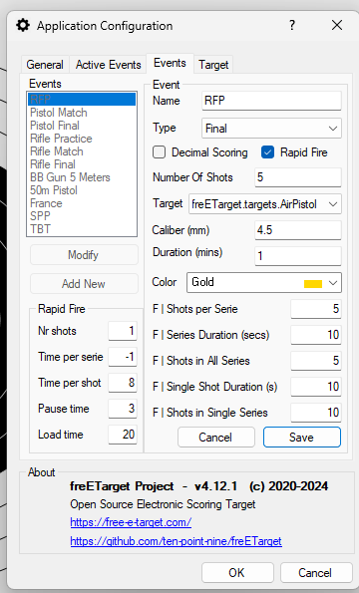
Figure 1: Rapid Fire Settings

Sport Pistol
Rapid Fire Sport Pistol is provided for users who do not have an autoloading pistol. In this event, the shooter is presented with five targets for a period of three seconds.
Configuration
- Launch the PC client and select the setup tab.
- Inside the tab, select ADD NEW to add a new target to the active events
- Name the target SPP (SPort Pistol)
  - You can add a suffix, for example “SPP Allan” to create a specific profile.
- Create the settings as shown in Figure 2.
- Press Save
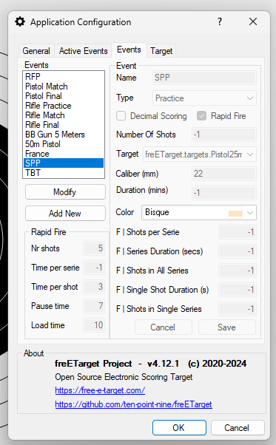
Figure 2: Sport Pistol Settings

Tabata
Tabata presents the target to the shooter for a short period of time. This is to provide training against overholding.
Configuration
- Launch the PC client and select the setup tab.
- Inside the tab, select ADD NEW to add a new target to the active events
- Name the target TBT (TaBaTa)
  - You can add a suffix, for example “TBT Allan” to create a specific profile.
- Create the settings as shown in Figure 3.
- Press Save
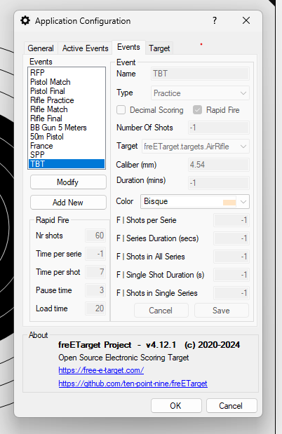
Figure 3: Tabata Settings

Use
- Launch the PC Client.
- Go to the settings tab and make sure that the new target(s) is in the Active Targets side as illustrated in Figure 4

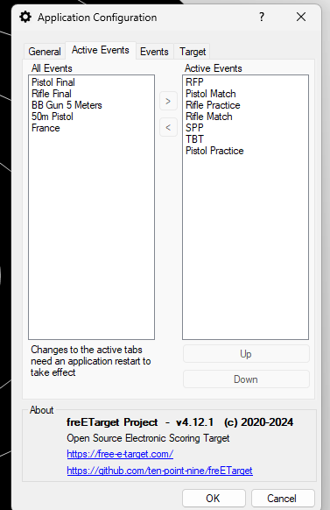
Figure 4: Active Target Selection

- Exit the PC Client and relaunch the program
- Press CONNECT to connect to the target
- Select the correct tab on the right hand side of the target
- Press Start Session at the bottom of the target.
- Shoot.

